Boulder Country Club – Clubhouse Renovation
Boulder, CO

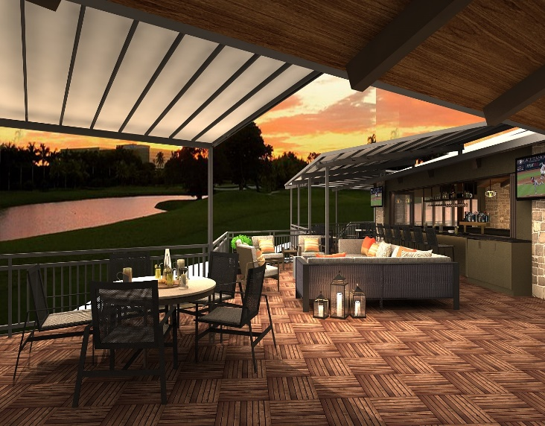
Project Details
Description: 23,155 sf Renovation
Owner: Boulder Country Club
Architect: SopherSparn Architects
CM/GC: Deneuve Construction
Budget: $7.75M
Completion: December 2020

Project Description
The project was a 23,155 sf renovation of the existing historically-registered Clubhouse at the Boulder Country Club located in Boulder, CO. The renovation included construction of two new bars, dining room, ballroom, Men’s and Women’s Card Rooms, upgrades to the 4,082 sf of existing deck and construction of 1,485 sf of new deck.
Scope of Services
Eric Shafran served as the Principal in Charge, Chris Landry served as Project Executive and Cord Green was the Project Controls Manager for the duration of the design and construction of the Clubhouse and all were charged with overseeing and managing virtually all aspects of the project over a 10-month period. Responsibilities included, but were not limited to:
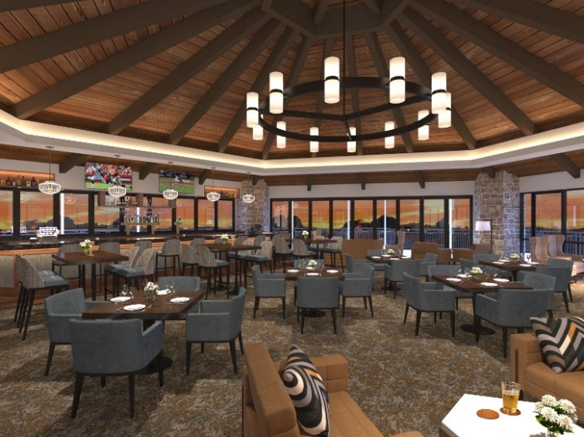
- Developed and managed the complete project budget, including monthly tracking and reporting of change orders, contingency usage, budget transfers, and commitment levels.
- Coordinated closely with Boulder Country Club staff to minimize disruption to golf operations.
- Supervised the project schedule with strong control over critical construction, utility, FF&E, and building systems commissioning milestones.
- Oversaw the architectural and interior design team, ensuring alignment with the Club’s programmatic and aesthetic goals while maintaining construction cost targets.
- Reviewed monthly construction draws and monitored potential and realized change orders daily, leading negotiations as needed.
- Prepared comprehensive monthly reports for the Owner.
- Negotiated, engaged, and managed contracts with secondary consultants in materials testing, surveying, network and security design, audio/visual, and signage design.
- Directed FF&E selection and procurement, including restaurant- and bar-specific furniture and equipment sourced through multiple vendors and specialty fabricators.
- Coordinated project close-out activities with all vendors and consultants.

